JAVA TRACK – DAY 5 ASSIGNMENT
SET 2 – BANK BRANCH ACCOUNTS
Name: ______________________________
Register Number: ____________________
Date: ______________________________

Business Scenario
A bank branch tracks account details such as customer, address, account number, account type, branch, relationship manager and balance in a de-normalised sheet.

Question 1. Normalise to 3NF/BCNF, identify candidate and composite keys and draw the ER diagram.
The database is divided into four tables:
- Customer – stores customer details.
- Branch – stores branch details.
- Relationship_Manager – stores manager details.
- Account – stores account number, account type and balance.
Candidate Keys:
- Customer: customer_id
- Branch: branch_id
- Relationship_Manager: manager_id
- Account: account_id and account_number
Composite Key: No composite primary key is required in this design because each table has a single-column primary key.
ER Diagram (relationships):
Customer (1) ───── (Many) Account
Branch (1) ─────── (Many) Account
Relationship_Manager (1) ───── (Many) Account
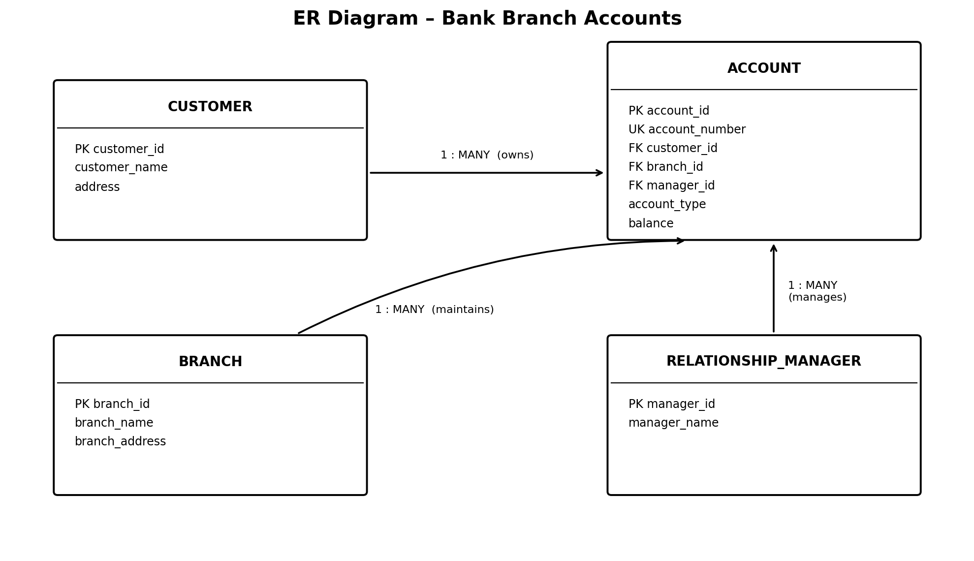

Question 2. Create the database and tables in MySQL with AUTO_INCREMENT keys, UNIQUE account numbers and CHECK constraints for balance and account type; justify the data types chosen.
CREATE DATABASE BankDB;
USE BankDB;
CREATE TABLE Customer (
customer_id INT AUTO_INCREMENT PRIMARY KEY,
customer_name VARCHAR(100) NOT NULL,
address VARCHAR(200) NOT NULL
) ENGINE=InnoDB;
CREATE TABLE Branch (
branch_id INT AUTO_INCREMENT PRIMARY KEY,
branch_name VARCHAR(100) NOT NULL,
branch_address VARCHAR(200) NOT NULL
) ENGINE=InnoDB;
CREATE TABLE Relationship_Manager (
manager_id INT AUTO_INCREMENT PRIMARY KEY,
manager_name VARCHAR(100) NOT NULL
) ENGINE=InnoDB;
CREATE TABLE Account (
account_id INT AUTO_INCREMENT PRIMARY KEY,
account_number VARCHAR(20) NOT NULL UNIQUE,
customer_id INT NOT NULL,
account_type VARCHAR(20) NOT NULL,
branch_id INT NOT NULL,
manager_id INT NOT NULL,
balance DECIMAL(12,2) NOT NULL DEFAULT 0.00,
CONSTRAINT chk_balance CHECK (balance >= 0),
CONSTRAINT chk_account_type
CHECK (account_type IN ('SAVINGS', 'CURRENT', 'SALARY')),
FOREIGN KEY (customer_id) REFERENCES Customer(customer_id),
FOREIGN KEY (branch_id) REFERENCES Branch(branch_id),
FOREIGN KEY (manager_id) REFERENCES Relationship_Manager(manager_id)
) ENGINE=InnoDB;
Data Type Justification:
Data type | Purpose
INT | Stores numeric ID values.
AUTO_INCREMENT | Generates ID values automatically.
VARCHAR | Stores names, addresses and account numbers.
DECIMAL(12,2) | Stores money accurately with two decimal places.
UNIQUE | Prevents duplicate account numbers.
CHECK | Validates balance and account type.

Question 3. Differentiate DROP, TRUNCATE and DELETE by running each on a test table and recording the effect on AUTO_INCREMENT and rollback.
Command | Effect | AUTO_INCREMENT | Rollback
DROP | Deletes the entire table and its structure. | Removed with the table; recreated table starts again. | Cannot be rolled back in MySQL.
TRUNCATE | Deletes all records but keeps table structure. | Resets the counter. | Cannot be rolled back in MySQL.
DELETE | Deletes selected records or all records using WHERE. | Does not reset the counter. | Can be rolled back inside an InnoDB transaction before COMMIT.
SQL Commands:
CREATE TABLE Test (
id INT AUTO_INCREMENT PRIMARY KEY,
name VARCHAR(50)
);
INSERT INTO Test(name) VALUES ('Arun'), ('Priya');
DELETE FROM Test WHERE id = 1;
TRUNCATE TABLE Test;
DROP TABLE Test;

Question 4. Insert, update and delete records; use AND, OR, IN, BETWEEN and LIKE to find accounts opened in the last quarter with a balance above a threshold.
Insert:
INSERT INTO Customer(customer_name, address)
VALUES ('Arun', 'Madurai');
INSERT INTO Branch(branch_name, branch_address)
VALUES ('Main Branch', 'Madurai');
INSERT INTO Relationship_Manager(manager_name)
VALUES ('Kumar');
INSERT INTO Account
(account_number, customer_id, account_type, branch_id, manager_id, balance)
VALUES ('ACC1001', 1, 'SAVINGS', 1, 1, 25000.00);
Update:
UPDATE Account
SET balance = 30000
WHERE account_number = 'ACC1001';
Delete:
DELETE FROM Account
WHERE account_number = 'ACC1001';
Using AND:
SELECT * FROM Account
WHERE balance > 10000 AND account_type = 'SAVINGS';
Using OR:
SELECT * FROM Account
WHERE account_type = 'SAVINGS' OR account_type = 'CURRENT';
Using IN:
SELECT * FROM Account
WHERE account_type IN ('SAVINGS', 'CURRENT');
Using BETWEEN:
SELECT * FROM Account
WHERE balance BETWEEN 10000 AND 50000;
Using LIKE:
SELECT * FROM Account
WHERE account_number LIKE 'ACC%';
To find accounts opened in the last quarter, an opening_date column is required. The following example uses 1 July 2026 to 30 September 2026.
ALTER TABLE Account
ADD opening_date DATE;
SELECT * FROM Account
WHERE opening_date >= '2026-07-01'
AND opening_date < '2026-10-01'
AND balance > 10000;

Question 5. Use ALTER TABLE to add a 'kyc_status' column, rename a table and drop a constraint; document each effect.
1. Add KYC Status Column:
ALTER TABLE Customer
ADD kyc_status VARCHAR(20) DEFAULT 'PENDING';
Effect: Adds a new column to store the KYC verification status.
2. Rename a Table:
RENAME TABLE Customer TO Bank_Customer;
Effect: Changes the table name from Customer to Bank_Customer.
3. Drop a Constraint:
ALTER TABLE Account
DROP CHECK chk_balance;
Effect: Removes the balance validation constraint.

Conclusion
The Bank Branch Accounts database is created using MySQL with primary keys, foreign keys, AUTO_INCREMENT, UNIQUE and CHECK constraints. DECIMAL is used to store account balances accurately.

